Documentation for Skillsage Website

Product Overview

The overview of this project is to provide South African people especially the youth people, with all possible resources and products in a specific manner such as showing opportunities/guides related to one category that you choose for example there are 6 categories on the system where you can choose on which category you belong to like choosing that you completed your education in by passing matric then this system will show you all the possible path you can take in order to succeed like recommending all the colleges you may apply for in an example where you passed grade 12 with lower marks. Skillsage is aiming to provide the information as possible to their users and that makes the system to be little more advanced. In which the system is made of databases and well managed scalability for the system in the future for it to manage when it start growing and when there are errors and mistakes are to be fixed.

Technologies Used on the system:

-HTML

-CSS

-JavaScript

-jQuery

-Waypoints.JS

-LightSlider.JS

-PHP for server side

-MySQL

-phpmyadmin

-XAMMP server

How the system works

The main aim of the system is to provide details as fast as possible. On the home screen the website provides a full landing page with 5 pages in which all the pages are basically introducing the overview of the website briefly, which includes ‘About page’,’ How it works’, ‘Team’, ‘Contact’ and a footer. All these pages were created with the markup language, styling and little piece of jQuery and Waypoints code for only nav bar.

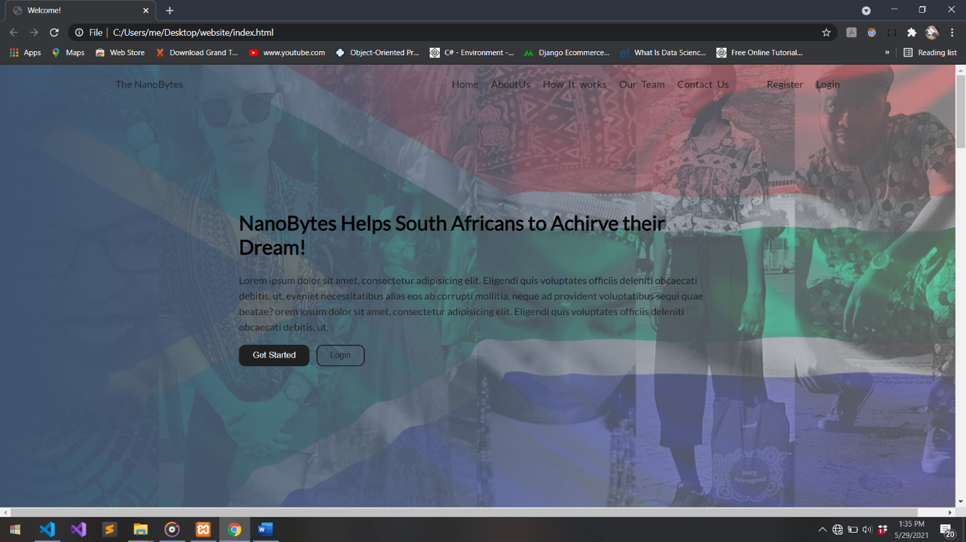

This picture shows the very start page of the website with a transparent nav bar but we want it to change from transparent to a light color when a user scrolls down from that page for that functionality it require CSS code to make the nav bar to have a color and JavaScript code to hide that styling but when a user scrolls down it show that styling to make this functionality we use waypoints.js which is JavaScript library which was developed basically to control scrolling on the webpages. Then we write our code on main.js to make this functionality complete.

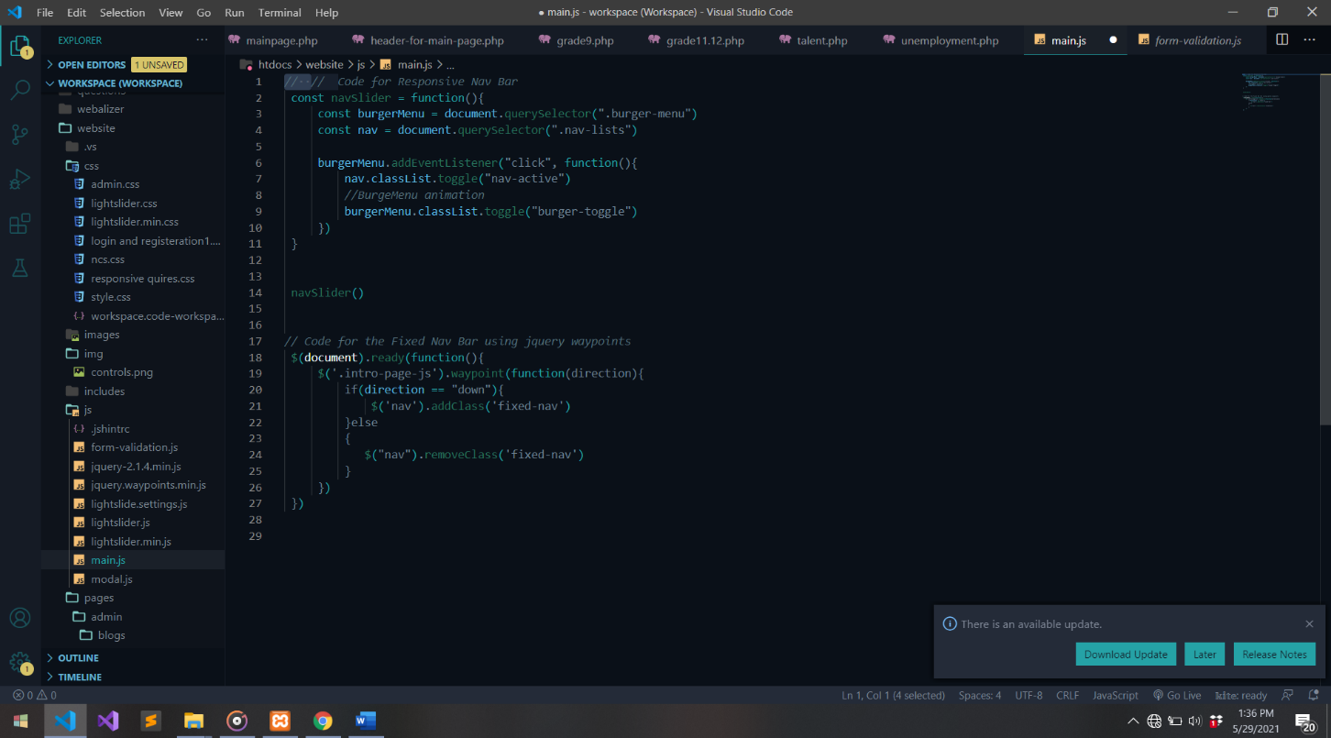

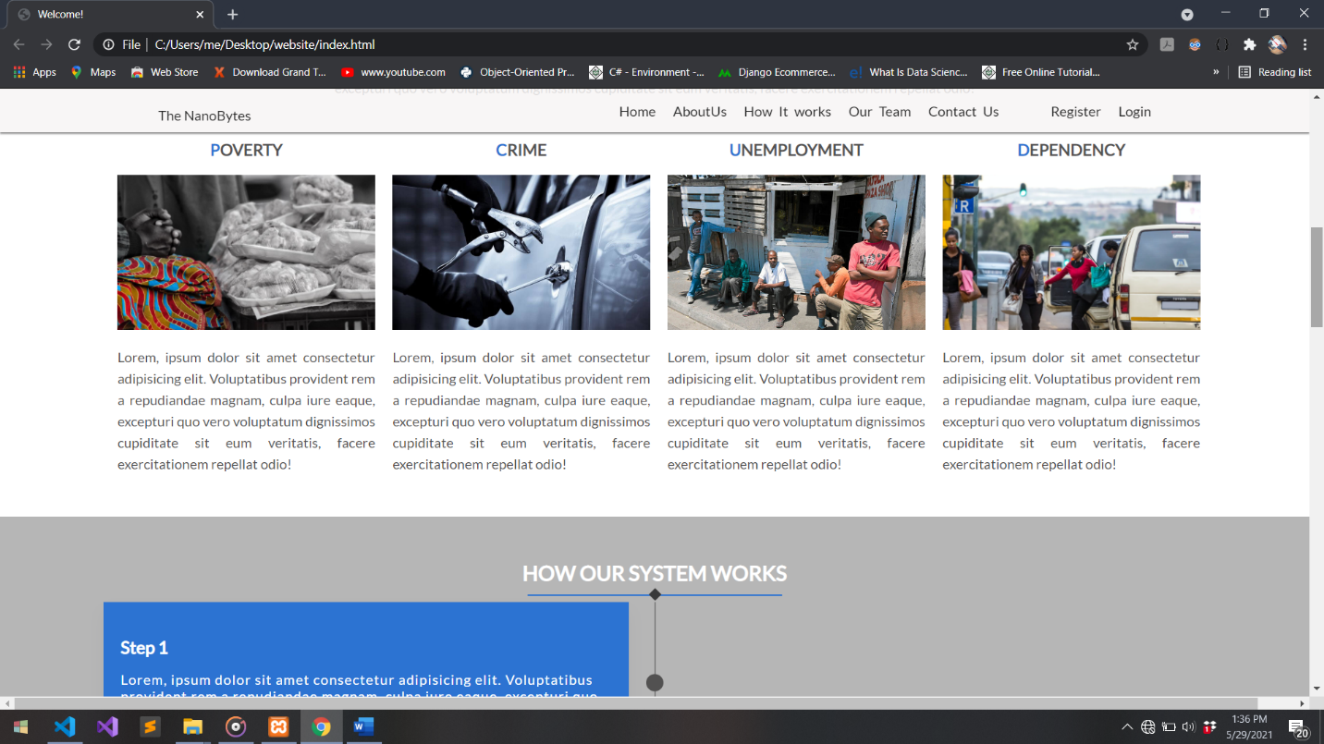

On the first picture the nav bar was transparent but when a user scrolls down to about page the nav bar changes to a color and to a specific size because JavaScript and waypoint code triggers the CSS style to make the nav bar to have color.

On the first is only information no much interaction with the user. The real part of the website start when a user clicks on register or login buttons, that’s we start requiring sever side language which is PHP in our case and databases which is MySQL and phpMyAdmin in our case. There is a registration system where the system is basically adding a user but requires a certain input from the user in order to validate and to make well managed database. It only requires valid username, valid email and password. Username was programmed that it should start with @ and followed by any characters then that’s where it would be a valid username and all this functionality was programmed with php and MySQL on the three file namely register.php, register.inc.php and process.php.



-In the picture the username entered on the input titled “John” is considered as invalid since it does not start with @.

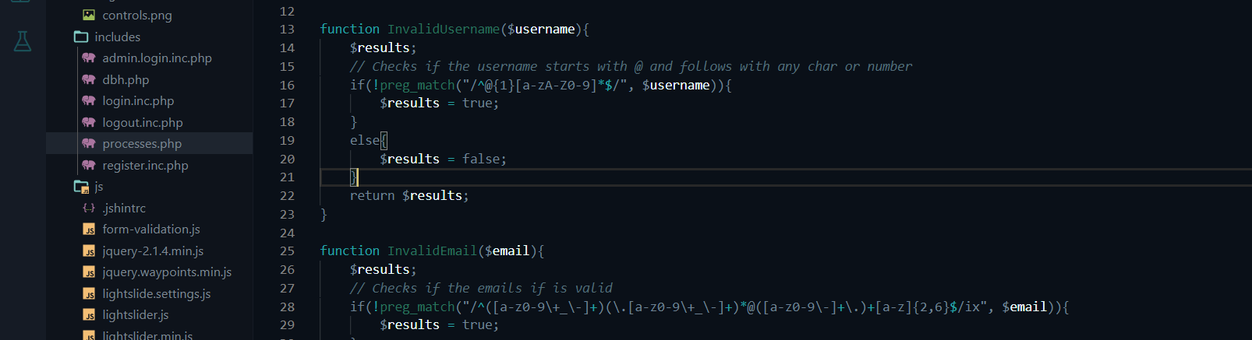

-This is the php code to make all the functionality to check if the username entered is correct same kind like in the email.

The php topics that were used are regular expressions and comparison operators. The email on the system also work like username it must be a valid email such as [example@gmail.com](mailto:example@gmail.com) and note the only functionality there’s no third party software to check if the email is existing on any servers like if it existing in google(.Gmail) server but the code structure allow us to add the functionality now or in future.

For password the system uses both php and JavaScript to validate the system. We used the power of JavaScript to implement user friendly to end users for the system to show them in the frontend if their entered password is valid. It simply show red if you have’nt entered the right password as it requires then it turns green if you entered in good manner, this does not promote user friendly only but also promote users to make strong passwords to make work difficult for hackers and all this is done by JavaScript code on file named form-validation.js.

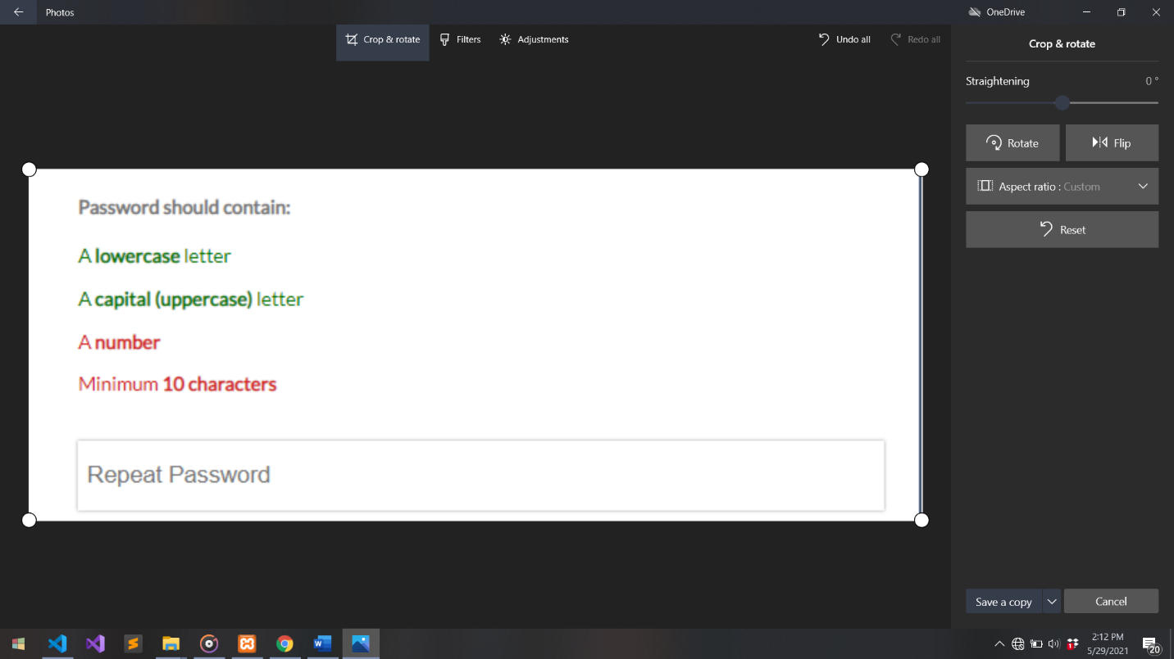

This picture show how the functionality works.

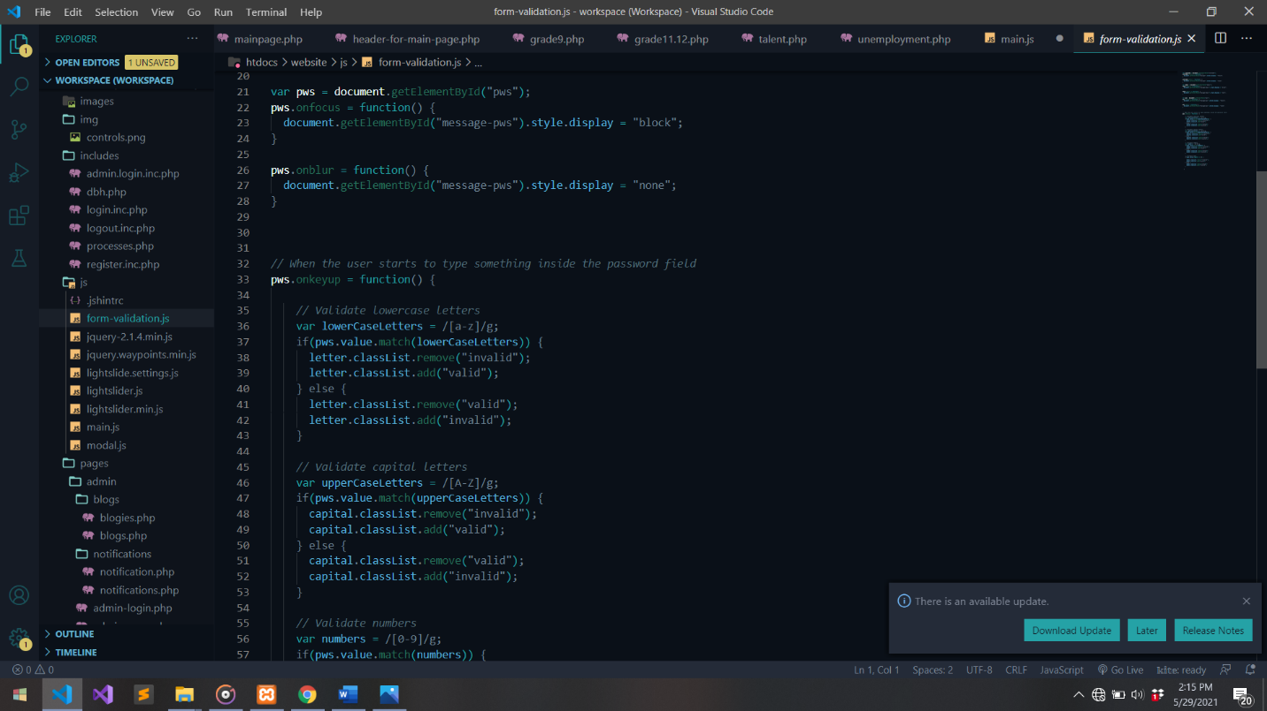

This is the JavaScript code that make all the functionality to the password validation process ant the JavaScript topict used is Js regular expressions and Js on key ready functions.

The php code only works to check if the repeating password is the same as the actual password if they are not the same php code will return the error and if are the same, php code will return success that a user created the account.

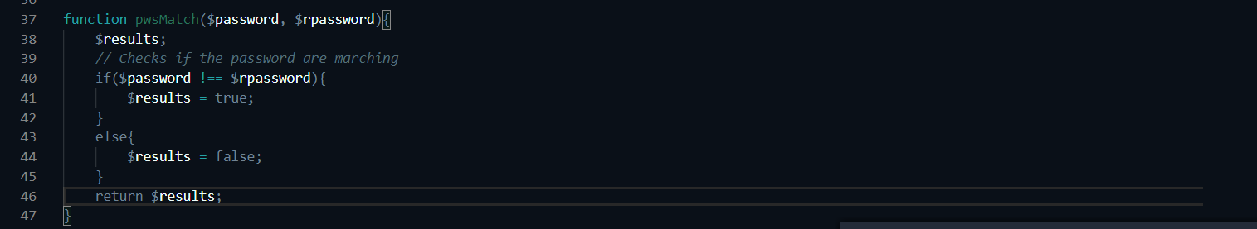

This is the php code to check if the password are the similar or not

Once the user created the account they will be logged in emmediately with a session that is coded in php language and that session is built if a certain user from database is logged in, this means only one user can log in at a time until he logs off. The php code can be used to assign the name of the user to the front page using the session variable.

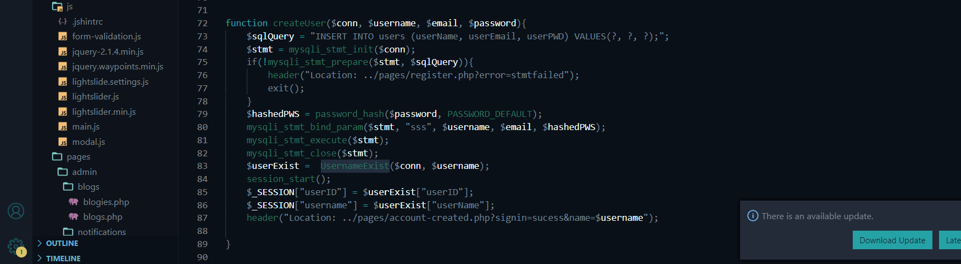

This is the php code function that if the user entered all the correct information it will start save the username, email and hashed password to the database and logs in the user with php session variable.

The login system is simple because it uses almost the same functions that are used in the registeration system the same function is to check if the user did filled all the inputs if not, php code will return error to the frontend and note this also apply to registeration system.

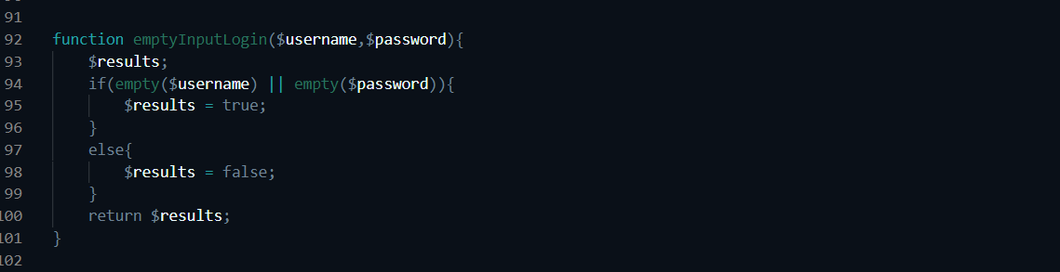

This code checks if all the inputs are filled.

If the user fills all the inputs now the php code will jump to another functions that basically logs in the user based on certain condition in which it requires the other function namely UsernameExist in which it checks if there entered information marches the one that is on the database if this function returns true then the system will log in the user and assign their information from the datebase to the session until they log off.

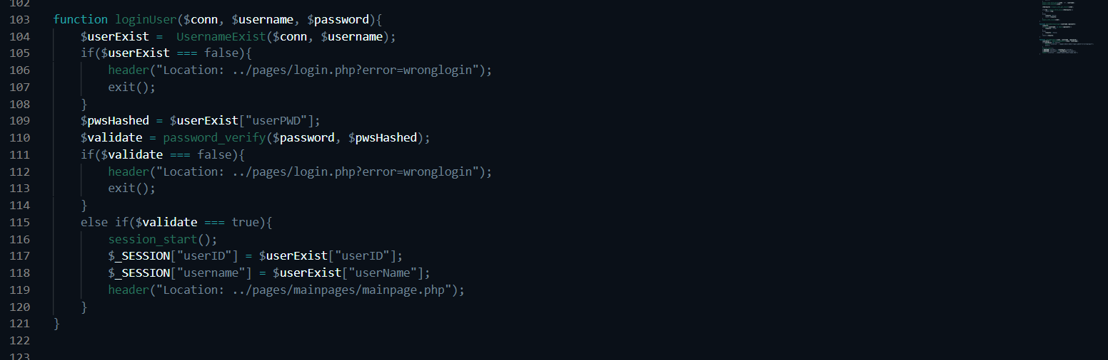

This code is function that perfoms all that is explained it checks if entered info exist in the database or not. Then if it will validate hashed password with entered password if the validation is passed it will assign the entered informatin to a session and log in the user.

Note this UsernameExist function also apply in the registeration system code but in visa vesa if it returns true the registeration sytem php code will return an error that the user already exist in the system.

The actual part starts just when the user has logged in where they see all the information. The after you logged in is basically showing all 6 categories which is based on users positions like people who leaved school in grade 9 , those who passed grade 10, 11 to 12 and failed grade 12, passed grade 12, those who are blessed with talent, who are unemployed and those who wish to start a business. In part the user just select the category they may fall to. After that, that’s were the system becomes more interesting and more complex.

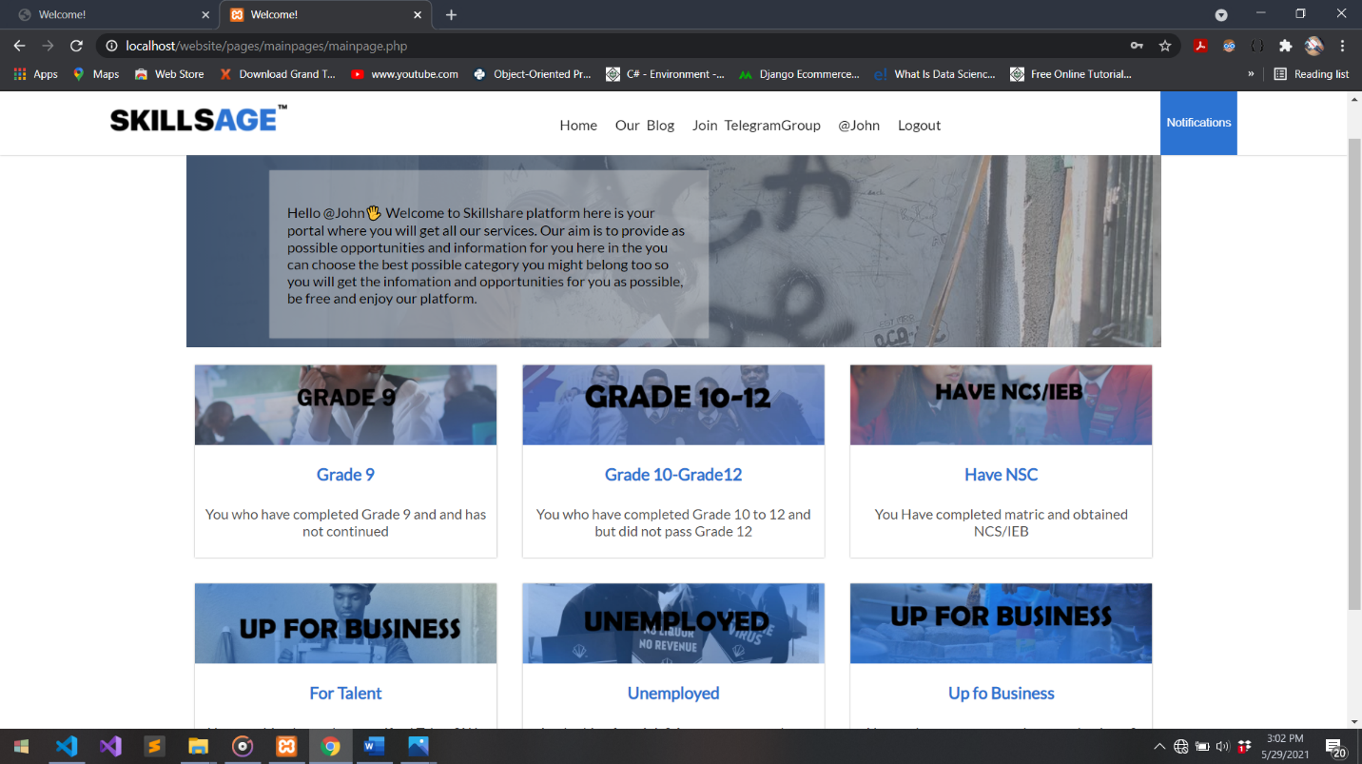

Let’s say a user clicks on grade 9 then the system will jump to another page which shows the information based to people who only have grade 9, but that information should be show in a simple way mostly it should be categorized for example, in grade 9 it should show al the opportunities that a person who only finished In grade 9 and on the other side it should show all the courses that the grade 9 candidate can take. And this information should be showed in categorized manner in our website and it should show as much as information like many pictures, paragraphs for each information lets say for each and every university we are showing on the web it should have a heading, picture and paragraph explaining a specific university, Just think if we had to hard code all this information to our html code it will thousands and thousands of code which in future could be hard to be managed even system to be hard to be updated. Therefore we used the databases to manage our code and to make every thing to be simple as possible.

To make our system more user friendly we want to show all this information to our users in simplest form in which are shown in grid form and user can slide through them left and right in which make it user friendly as the user won’t need click many times to see all the information or to experience to too much page loading but simply the information is in their eyes all they do is to scroll so they can see other information.



In the picture you can see that there are 5 universities there and just for example in South Africa there 26 universities and just imagine if a user had to do many clicks on the page to see other 21 remaining universities or the user had to see all these 26 universities in one page it would be overwhelming!. Therefore in our picture a user can scrool to right to see other universities 21 remaining universities.

The process to make this slides for information is complex as we used jQuery code and restricted html. To make this slidings first we use JavaScript library which is lightsliderJS in which it is used to implement slidings within any website but with restricted coding procedure in your html code and jQuery code.

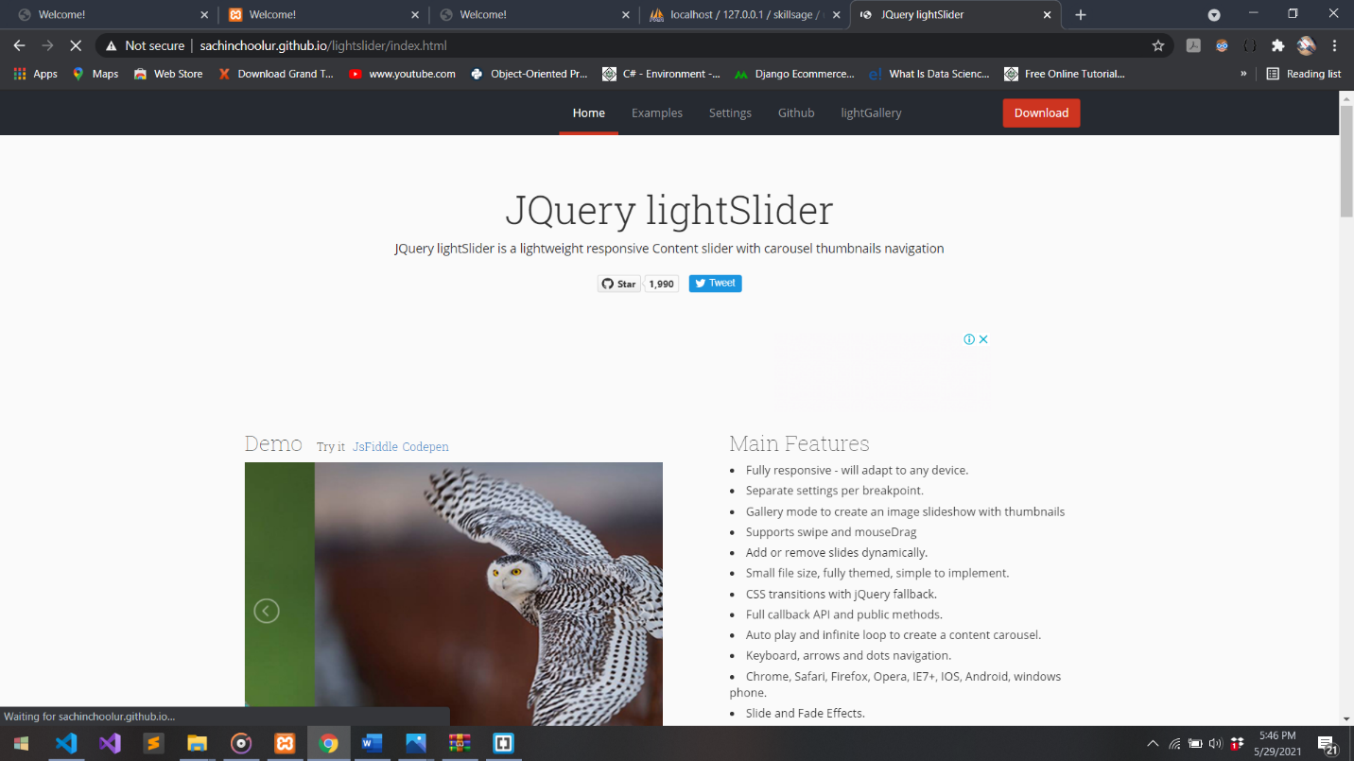

The process to implement lightslider on webpage start with

-Step one

Download lightslider CSS and JavaScript files and copy them on the project CSS file in ccs folder and JS file in JS folder and link the on html file.

-Step two

Make a js file and give it any name of choice in our case is lightslide.settings.js and also link it on the html file.

-Step three

On html make a ul tag and give it a any class name of your choice in our project is light-slider.

-Step four

Then on the js file that you created, make variable of your choice which in our project is named var slider and on that variable we call the class that we created on the ul tag.

-Step 5

Then on html file inside ul tag we can make li tags in which any li tag we add the lighslider code will consider it as a slide in which on each li code inside you can design it as you want. As in our case we designed it to have a picture, a heading and paragragh as show in the picture of slides.

Note Lightslider has many settings you can change for like in our case we changed some settings to accomodate the mobile responsive of our website, for all the settings Lightslider has great documentation in their website.

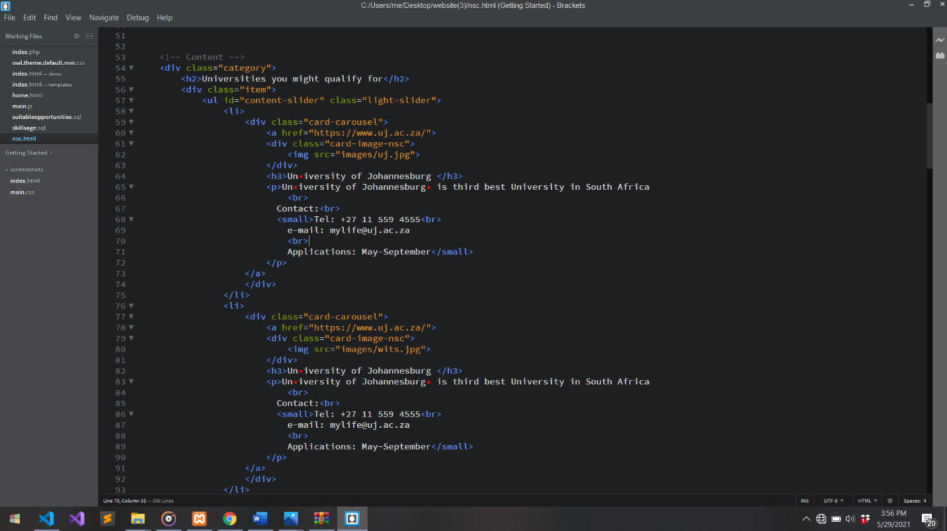

This code is the example of the previous picture as we used lightslider there where we have ul tag hold many li tags and inside those li tags there a code that we created in order to design our cards

Our website is now complete and user friendly for the users but although the system is not stable and manageble just look at the previous picture, everything is hard coded in the html code for in our example, one university almost take 18 lines in our html(on the picture from line 58 to line 75) there for since the are 26 universities the lines we going to write are 26 times 18 if we hard coded the information and those are many lines and there’s other information besides universities that we still going to add like collegies for example. To make the code base simple we going to make database for each category and use php code to show information from our database to our designed frontend page for in our university example we create a table university and add some variables which includes picture, name, intro, longintro, amail, and contact in which every university has all this.

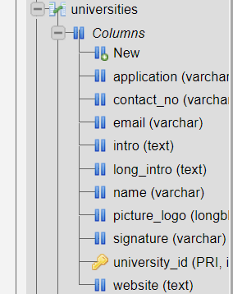

This is the picture with University Table database.

After we created our database table we now gonna call it in our php code then we do while loop it inside that 18 lines code in the html and close the while loop so that php code will output all the universities added to the database in the same format but now all shown in the frontend is not hard coded but from the database.

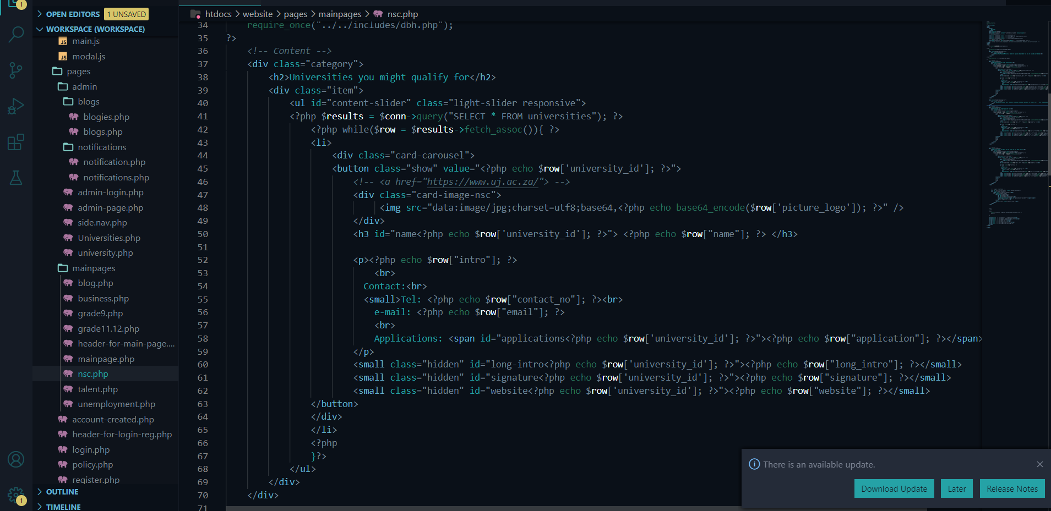

This code make all the functionality to retrieve the information from the database and to output it on the frontend and note in this code is only 71 lines than 26 times 18 lines and that decreases lot of work and make the system more simple, basically in this code we retrieve deta from database in line 41 using SQL and PHP then on line 42 we do a while loop with a fetch_assoc php function in which means while there is a data in the database the code must run that html code and assign the date to specific tags in that html code we looping inside to then at the end of the html code that we want to use which is closing li tag(</li>) in our case then after thar we end our while loop.

The system as we added databases is now manageable and user friendly but there’s no user interaction since a user can see just the cards showing universities and just sliding left and right through them and that’s not enough the user must get the information as possible since the aim of the system is to provide the reqired clear information to users. Therefore to achieve that goal we create a modal popup with javascript in which for example when a user clicks on one university, the system should show a modal popup with more information of that university that explaining and giving more about the university and now even showing a button to click to go to that university website or any other website for complete information

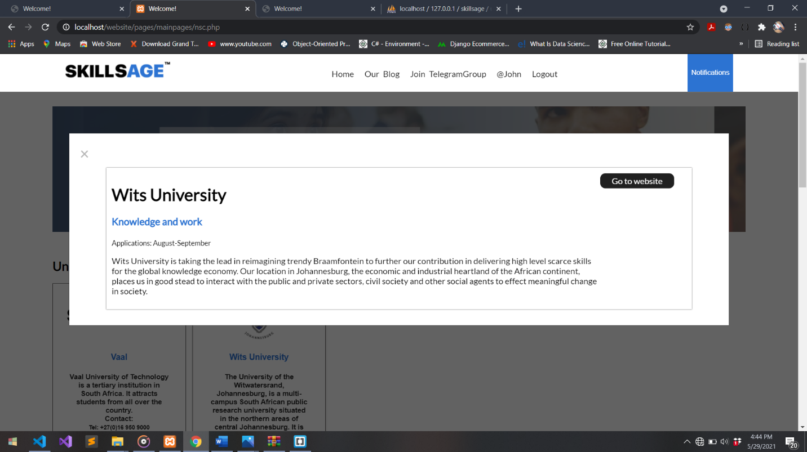

This picture is the example of when a user clicked on Wits University in the cards then the popup will show with more detailed information about Wits University and link button.

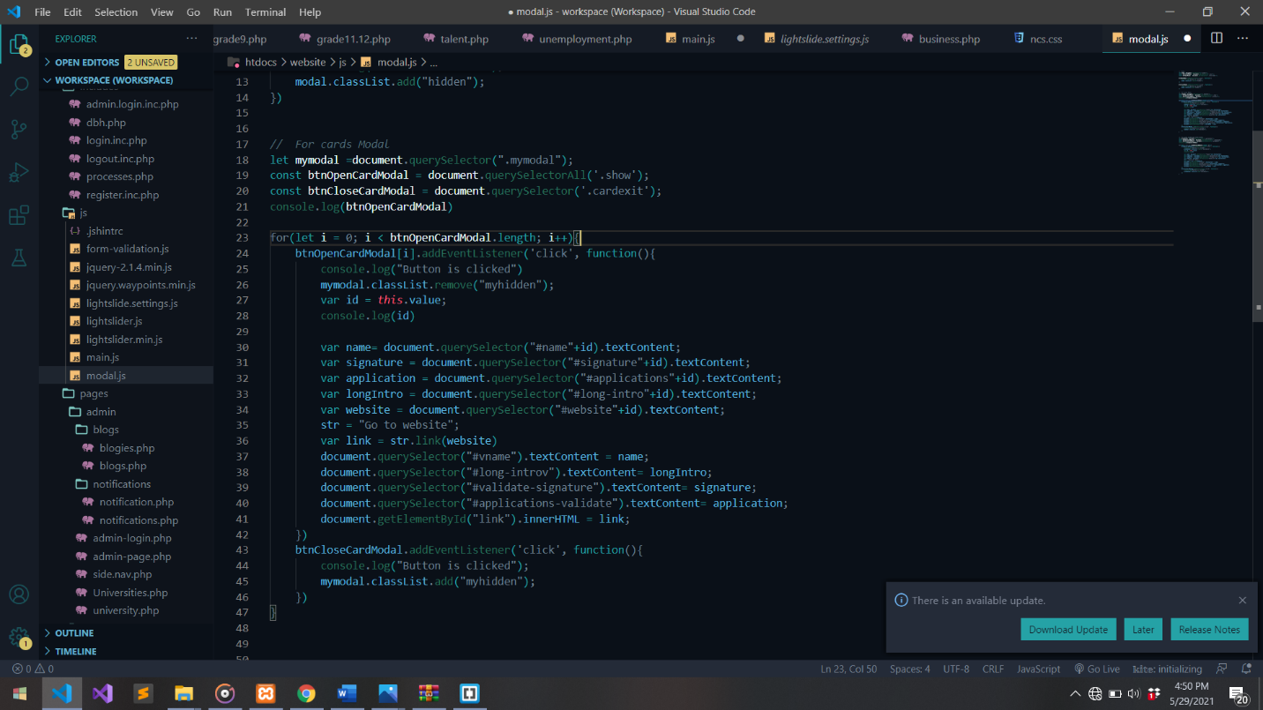

In this picture our JavaScript code is clear in which we make a variables for open button, close button and modal it self, but on button variable we call the class name differently we call not calling it by Document.querySelector function but we use Document.querySelectorAll function because we gonna have many buttons in which those buttons will be those cards which are universities on the sliding. Each university button in the html code on the previous picture of it see the the will be a specific id which will be from database for example if the user clicks on Wits University and the id number from database for Wits is 1 then the button value for Wits will be 1 and the javaScript code will understand that it should show the information based on the given id from the button in which the button got the value from databases. There for the JavaScript code will trigger the modal and also transfer information from the specific clicked button to the modal and show it on the modal design.

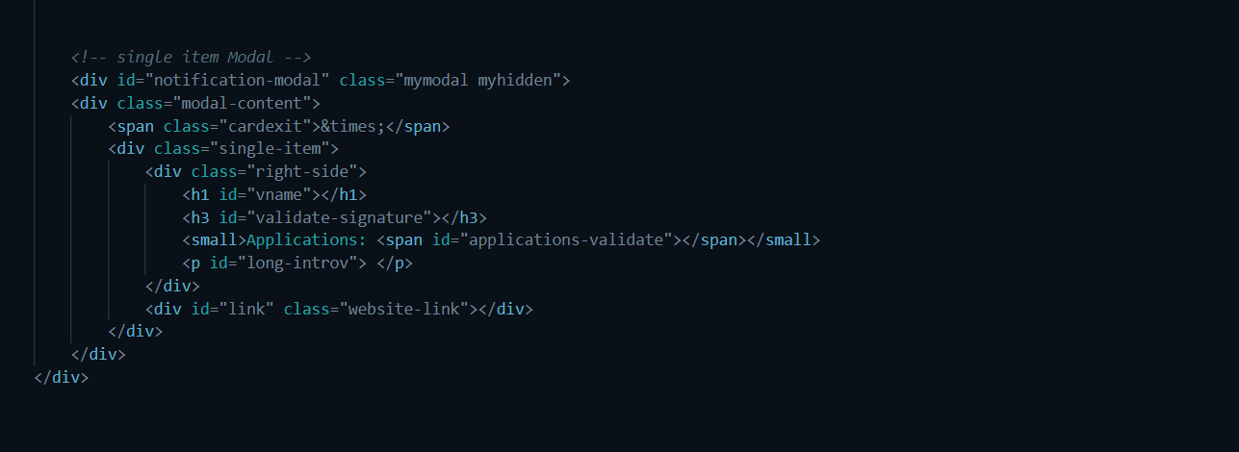

This code is the actual modal popup html code the when a user click on Wits the JavaScript code will add the information from clicked button using id from database and show all the information. Note it will show information based in html id given for in this code the html id for name is vname and since the user clicked on Wits js code will first transfer Wits id from database and then all other properties will follow like name we can transfer it to this modal.

The user will be able to interact with the system but the information will start to be boring it they are not updated and the users will not use the website if we do not communicate with them. We added Notification and Blogs functionality. Notification functionality is where users will get updated about every updates and events by our website for example lets say we are working with Uj to offer bursaries then our users will get updated about that on the notification panel in the web. Blogs will be little similar to notifications but blogs will provide outside information as links to the source for example if CMN news website posted about available bursaries in South Africa we gonna add it in our Blog with a link for more info. Note we also add the Blogs and Notifications in the database then it will show on the front end and all the php code is the same as for the card explained previously.

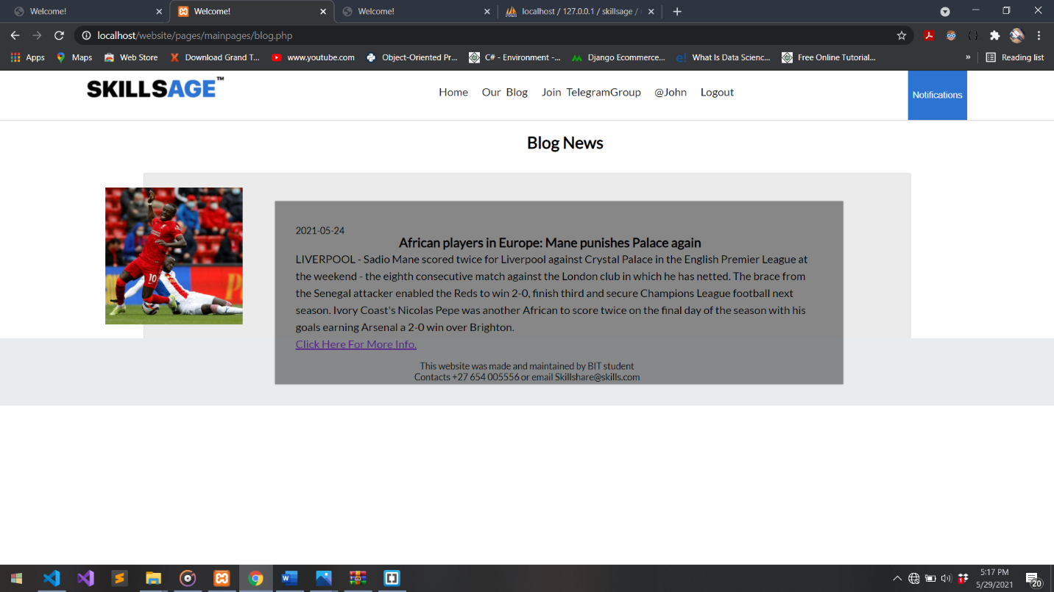

The above picture shows the Blog page with one information on the database and all the code we used is the php code to retrieve information with php code using fetch_assoc php function.

Other function of the website is that it has an admin interface with a login only for admin and no resteration since admin can be one or two people and their account is created by It guy in the database and they just log in and they can manage blogs, notifications and users.

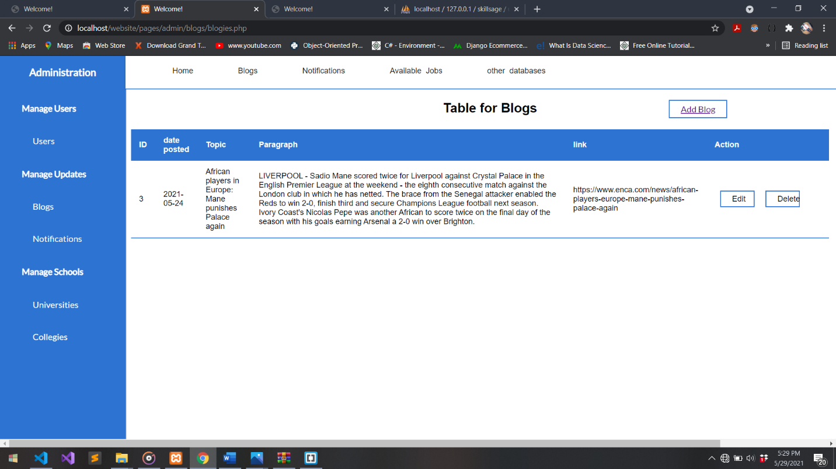

The above picture shows the admin panel showing the management of the Blogs and this side can not be accessed by anyone but the admin with ackoledgement from IT guy.

In Closing this website developers tried to follow DRY principle as possible which is Do Not Repeat Yourself but at some any point some css and php code is repeted in some cases but it does not threatens this system but this can be fixed let’s say all this system is being updated we can use frameworks such as bootstrap for css in which will decrease our css code lines by 40% estimated for this project. We can also use Cake or Laravel php framework to simplify the php code and even be able to add more complex backend functionality